Treatment Record Log
Accountable Person: ___________________________

Racing name of Horse | Treatment  (Brand name of active constituent) |  | Date of treatment |  | Time Treatment Administered
Reason for Treatment |  | Route of administration (e.g. oral, IV etc.) |  | Dosage & Duration
Name and signature of person administering treatment |  | Name and signature of person prescribing or authorising treatment
Racing name of Horse | Treatment  (Brand name of active constituent) |  | Date of treatment |  | Time Treatment Administered
Reason for Treatment |  | Route of administration (e.g. oral, IV etc.) |  | Dosage & Duration
Name and signature of person administering treatment |  | Name and signature of person prescribing or authorising treatment
Racing name of Horse | Treatment  (Brand name of active constituent) |  | Date of treatment |  | Time Treatment Administered
Reason for Treatment |  | Route of administration (e.g. oral, IV etc.) |  | Dosage & Duration
Name and signature of person administering treatment |  | Name and signature of person prescribing or authorising treatment

NZTR RULES AND REGULATIONS

Rule 345 requires that Licenceholders maintain a Treatment Logbook at all times and defines Treatments and Medications. This record must be easily accessible and available to NZTR or members of the RIB if requested.
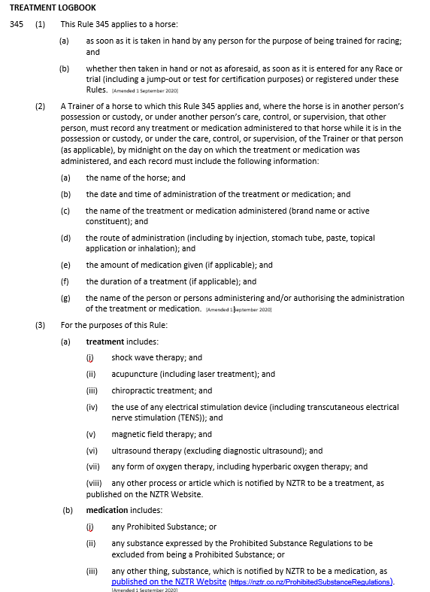
Supplements that you feed every day, in the horses normal feed, only need to be recorded once per horse until these change.
I.e.: Electrolyte supplement fed daily in the horse’s feed.
This Treatment Record Log needs to be kept for at least 12 months and be easily accessible if required.

